This 2015 IDTC Annual Booklet is dedicated to:

T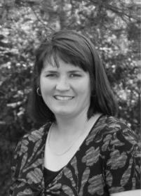

North Rose, NY: **Terri Anne Clingerman** went to her heavenly home on September 5, 2015 at the age of fifty after a courageous battle against cancer. Terri accomplished everything she put her mind to, and did so with passion and grace. She loved life and helped others to do the same.

Born March 1, 1965 at Bunker Hill Air Force Base in Indiana, she had a happy childhood enjoying living in numerous locations including Holland and Germany. She graduated from Chantilly H.S. in Fairfax, VA in 1983. She attended Clarkson University on a National Merit scholarship for a Bachelor of Science degree in Electrical and Computer Engineering, graduating in 1987. She also received a Master of Science degree in Electrical Engineering from RIT in 1991.

Terri has worked as an electrical engineer for the Xerox Corporation since 1987. For over 28 years she has designed numerous custom ASIC and FPGA chips for a wide variety of products, including high end xerographic printers/copiers and high performance scanners. These chips realized complex image processing algorithms that often required state of the art techniques of design and innovative methods of implementation. Terri was prolific at generating many intricate methods of implementation and was awarded a total of 9 US patents for some of them. Her highly recognized and valued work, as well as her natural people skills, resulted in her being promoted to a design team leader responsible for the delivery of both FPGA and system software for several production class printers.

For over 25 years, Terri participated in dog shows, earning championships with her yellow Labrador retrievers, border collies and Cardigan Welsh corgis in obedience, conformation, herding and agility. She was an AKC obedience judge and sought after trainer and seminar presenter. Terri was known for her positive attitude and kindness to people and dogs. She was a mentor to many and took great pride in her students' successes. In her quiet way, Terri was a diligent worker, often taking the lead. She was a popular past president (and lifetime member) of the Dog Obedience Training Club of Rochester NY, past board member of the Border Collie Society of America, past treasurer of the Finger Lakes Retriever Club and could always be counted on to lend a hand at dog events. She was so thoughtful of others, often helping out newcomers to the dog show world, setting a great example with her wonderful sportsmanship and upbeat attitude. Terri always had something positive and encouraging to say that would inspire us to go home, work harder and try again. Her friendship, generosity, consideration of others and enormous love for her dogs will remain an inspiration to us all.

Terri taught for the Ithaca dog Training Club for 11 years, braving the snow and cold on Saturday mornings January through March to teach an eager IDTC membership. Many of our current instructors learned from her how to teach to the public, and excelled at advanced obedience work due to her expert and caring tutoring. Her teaching was always about being kind to the dog, and showing them the way. Terri epitomized the idea of good sportsmanship and instilled this in those whom she taught. She will always be remembered by those whose lives she touched with her friendship, and her love of dogs and dog sports. You will see many of the techniques that she taught, used in the advanced classes, a sign that her legacy truly does live on at IDTC.

**INSTRUCTOR RECOGNITION**

2015 Obedience & Agility Instructors and Assistants

(27 Very Important Volunteers*)

**Nancy Allmann Lynne Anguish Betty Baldwin Kerry Boisvert

Rue Chagoll Bruce Coleman Jan Estes Sharon Garland

Jackie Gumtow Bill Hansen Janet Hansen Sandy Hawkins

Pauline Helfentein Donna Hopple Lisa Mitchell Karen Nocera

Joe Osmeloski Tammy Osmeloski Sue Pfuntner Marg Pough

Judy Roberts **Becky Robinson Hannah Robinson Tammy Snyder

Marian Szebenyi Lynne Wilkes Anne Williams

*18 of these also instructed or assisted in 2014 **Barn Hunt, Nosework

**IDTC 2015 Club Activities**

(What We Did Last Year)

January Agility League

Winter Classes

March Spring Classes

Spring Point Show

April Cornell Vet School Open House

Pet Expo at the Mall

May Barn Hunt Classes (inaugural for IDTC)

CGC at Elmira Bark for Life

Ithaca Festival Parade

June CPE Agility Trial

July Club Picnic

August Barn Hunt Classes

Club Picnic

September Fall Classes

Fall Point Show

October Interclub Match

Pet Expo at the Mall

Tracking Certification Match

November Early Winter Classes

Nose Work Classes (inaugural for IDTC)

December Agility League Holiday Party

Holiday Party

IDTC 2015 MEMBER ACCOMPLISHMENTS

*30 Handlers 51 Dogs 145 Titles*

____________________________________

**TEMPERAMENT**

*7 Temperament Titles*

4 CGC

3 Therapy Dog

**OBEDIENCE**

*15 Obedience Titles*

|  |  |  |  |
| --- | --- | --- | --- |
| Regular Titles | CD | CDX | UD |
| AKC: | 3 | 2 | 1 |
|  |  |  |  |
| Optional Titles | BN | PCD | GO |
| AKC | 4 | 1 | 2 |
| ASCA | 2 |  |  |
|  |  |  |  |

**RALLY**

*11 Rally Titles*

(8 AKC, 2 ASCA, 1WCRL)

AKC

3 Novice

2 Advanced

2 Excellent

1 Advanced Excellent

ASCA

1 Novice

1 Excellent Master

WCRL

1 Level 1

**AGILITY**

*75 Agility Titles*

(18 AKC, 2 ASCA, 55 CPE)

AKC

6 Novice

2 Open

3 Excellent

6 Master

1 MACH

CPE

15 CPE Level 1

21 CPE Level 2

11 CPE Level 3

1 CPE Level 4

4 CPE Level 5

3 CPE Level 5 Ch

ASCA

2 Novice

**VERSATILITY**

*5 Versatility Titles*

(1 AKC, 4 Other)

**WORKING**

*32 Working Titles*

10 Barn Hunt

2 Herding

4 Hunting

5 Lure Coursing

2 Nose Work

3 Tracking

2 Packing

4 Weight Pulling

|  |  |  |  |
| --- | --- | --- | --- |
| **IDTC 2015 TITLES BY HANDLER** | | | |
|  |  |  |  |
| **Name** | **Dog's Name** | **Breed** | **Title(s)** |
| Nancy Almann | Kiyo | Akita | **ASCA** RN; **WCRL** RL1; **BHA** RAT I, RAT N;  **NACSW** NW1; **DSA** UP1000, UT1000;  **ACA** VAX |
|  |  |  |  |
| Lynne Anguish | Nika | German Shepherd Dog | **BHA** RAT I, RAT N |
|  | Wren | German Shepherd Dog | **AKC** CGC |
|  |  |  |  |
| Deb Bain | Tryx | English Springer Spaniel | **AKC** UD |
|  | Socks | Greyhound | **AKC** CGC |
|  |  |  |  |
| Katie Barnaby | Mabel | Labrador Retriever | **AKC** MXJ |
|  |  |  |  |
| Kerry Boisvert | Digger | Border Terrier | **BHA** RAT I, RAT N |
|  | Lark | Border Terrier | **ASCA** BN; **CPE** ChST, ChWC, ChCL;  **BHA** RAT O |
|  |  |  |  |
| Rue Chagoll | Lexi | Golden Retriever | **AKC** BN |
|  |  |  |  |
| Audrey Coleman | Pete | Golden Retriever | **UKC** HR |
|  |  |  |  |
| Ray Corey | Peak | Nova Scotia Duck Tolling Retriever | **AKC** CGC; **NSDTRC-USA** WC |
|  |  |  |  |
| Katelyn Davis | Autumn | Flat Coated Retriever | **AKC** NAP, NJP; **CPE** CL3-R,H,F, CL4-F  **NACSW** L1C |
|  |  |  |  |
| Suzanne Etherington | Morgan | Airedale Terrier | **CPE** CL5 |
|  | Verbena | Airedale Terrier | **CPE** CL1-S,F, CL2-R,S |
|  |  |  |  |
| Sharon Garland | Lori | Border Collie | **AKC** HS; **AHBA** HRD-1 |
|  |  |  |  |
| Nancy Given | Beatrice | English Springer Spaniel | **AKC** OA |
|  | Cricket | All American | **BHA** RAT I, RAT N |
|  | Merlot | All American | **AKC** BN |
|  | Tinsel | Great Pyrenees | **GPCA** AAT&A |
|  |  |  |  |
| Grazyna Gross | Opie | German Shepherd Dog | **AKC** CDX |
|  |  |  |  |
| Janet Hansen | Rondo | Golden Retriever | **AKC** RN |
|  |  |  |  |
| Diane Krause | Emma | German Shorthaired Pointer | **AKC** THDA, THDX |
|  | Jack | German Shorthaired Pointer | **AKC** TD; **GSPCA** VCA |
|  | Kendyl | German Shorthaired Pointer | **AKC** RAE / OFP / MH; **GSPCA** VCA |
|  | Sonny | German Shorthaired Pointer | **AKC** RA / SH; **GSPCA** VCA |
|  |  |  |  |
| Jami McGovern-Landry | Freybug | Australian Cattle Dog | **AKC** BN; **CPE** CL2, CL3-H |
|  | Rossytsa | Bulgarian street dog | **AKC** CGC |
|  |  |  |  |
|  |  |  |  |
| Manny McGovern-Landry | Blitzen | Shetland Sheepdog | **AKC** BN; **CPE** CL1-R, CL2-F |
|  |  |  |  |
| Lisa Mitchell | Dante | Bernese Mountain Dog | **AKC** RE |
|  |  |  |  |
|  |  |  |  |
| Susan Morse | Cane | Belgian Malinois | **ASCA** REMX; **NWDA** WPT1, WPT3 |
|  | Holly | Belgian Malinois | **AKC** AX, AXJ; **Wylde** WPE |
|  | Jam | Belgian Malinois | **Wylde** WPE |
|  | Luna | Belgian Laekenois | **CPE** CL1, CL2-R,H,S; **NWDA** WPT3;  **Wylde** WPE |
|  |  |  |  |
| Chris O’Brien | Fleck | Australian Shepherd | **ASCA** JS-N, GS-N |
|  | Jazz | Australian Shepherd | **AKC** NA, NAJ; **CPE** CL2-S, CL3-R,H,F |
|  |  |  |  |
| Linda Pacioretty | Maqui | Dogue de Bordeaux | **AKC** GO |
|  |  |  |  |
| Tammy Roberson | Levi | Belgian Malinois | **AKC** CA; **CPE** CL1, CL2, CL3 |
|  |  |  |  |
| Hannah Robinson | Belle | All American | **AKC** CD / Tracking Certification |
|  |  |  |  |
| Tammy Snyder | Flare | Rottweiler | **AKC** MACH |
|  | Flint | Rottweiler | **AKC** CDX / NAP, NJP / TD / VCD1 |
|  |  |  |  |
| Lucille Straub | Cody | German Shepherd Dog | **AKC** GO / MXB, MJB, MJS |
|  | Piper | German Shepherd Dog | **CPE** CL1, CL2 |
|  |  |  |  |
| Marian Szebenyi | Angel | Siberian Husky | **CPE** CTL2-R,S |
|  | Luna | Siberian Husky | **AKC** RA, RE |
|  |  |  |  |
| Pat Welch | Clare | Irish Setter | **AKC** RN |
|  |  |  |  |
| Anne Williams | A Tatu | Belgian Malinois | **AKC** PCD, CD / CA |
|  | Falcon | Belgian Tervuren | **APDA** PDN-S |
|  | Reve | Belgian Tervuren | **BHA** RAT N |
|  |  |  |  |
| Sue Yanoff | Ivy | Beagle | **AKC** CD / RN / AXJ, MX, MXJ |
|  |  |  |  |
|  |  |  |  |
|  |  |  |  |
|  |  |  |  |
|  |  |  |  |
|  |  |  |  |
|  |  |  |  |
|  |  |  |  |
|  |  |  |  |

|  |  |  |
| --- | --- | --- |
| **IDTC 2015 TITLES BY TITLE** | | |
|  | | |
| TEMPERAMENT TITLES | | |
| **AKC CGC (Canine Good Citizen)** | | |
| Lynn Anguish | Wren | German Shepherd Dog |
| Deb Bain | Socks | Greyhound |
| Ray Corey | Peak | Nova Scotia Duck Tolling Retriever |
| Jami McGovern Landry | Rossytsa | Bulgarian street dog |
|  |  |  |
| **AKC THDA (Therapy Dog Advanced)** | | |
| Diane Kraus | Emma | German Shorthaired Pointer |
| **AKC THDX (Therapy Dog Excellent)** | | |
| Diane Kraus | Emma | German Shorthaired Pointer |
| **GPCA AAT&A (Advanced Animal Assisted Therapy & Activities)** | | |
| Nancy Given | Tinsel | Great Pyrenees |
|  |  |  |
|  |  |  |
| OBEDIENCE TITLES | | |
| **AKC BN (Beginner Novice)** | | |
| Rue Chagoll | Lexi | Golden Retriever |
| Nancy Given | Merlot | All American |
| Jami McGovern Landry | Freybug | Australian Cattle Dog |
| Manny McGovern Landry | Blitzen | Shetland Sheepdog |
|  |  |  |
| **ASCA BN (Beginner Novice)** | | |
| Kerry Boisvert | Lark | Border Terrier |
| Chris O'Brien | Fleck | Australian Shepherd |
|  |  |  |
| **AKC PCD (Preferred Companion Dog)** | | |
| Anne Williams | A Tatu | Belgian Malinois |
|  |  |  |
| **AKC CD (Companion Dog)** | | |
| Hannah Robinson | Belle | All American |
| Anne Williams | A Tatu | Belgian Malinois |
| Sue Yanoff | Ivy | Beagle |
|  |  |  |
| **AKC CDX (Companion Dog Excellent)** | | |
| Grazyna Gross | Opie | German Shepherd Dog |
| Tammy Snyder | Flint | Rottweiler |
|  |  |  |
|  | **AKC GO (Graduate Open)** |  |
| Linda Pacioretty | Maqui | Dogue De Bordeaux |
| Lucille Straub | Cody | German Shepherd Dog |
|  |  |  |
| **AKC UD (Utility Dog)** | | |
| Deb Bain | Tryx | English Springer Spaniel |
|  |  |  |
|  |  |  |
|  |  |  |
|  |  |  |
| RALLY TITLES | | |
| **AKC RN (Rally Novice)** | | |
| Janet Hansen | Rondo | Golden Retriever |
| Pat Welch | Clare | Irish Setter |
| Sue Yanoff | Ivy | Beagle |
| **ASCA RN (Rally Novice)** | | |
| Nancy Almann | Kiyo | Akita |
| **WCRL RL1 (Rally Level One)** | | |
| Nancy Almann | Kiyo | Akita |
|  |  |  |
| **AKC RA (Rally Advanced)** | | |
| Diane Kraus | Sonny | German Shorthaired Pointer |
| Marian Szebenyi | Luna | Siberian Husky |
|  |  |  |
| **AKC RE (Rally Excellent)** | | |
| Lisa Mitchell | Dante | Bernese Mountain Dog |
| Marian Szebenyi | Luna | Siberian Husky |
|  |  |  |
| **AKC RAE (Rally Advanced Excellent)** | | |
| Diane Kraus | Kendyl | German Shorthaired Pointer |
|  |  |  |
| **ASCA REMX (Rally Excellent Master X)** | | |
| Susan Morse | Cane | Belgian Malinois |
|  |  |  |
|  |  |  |
|  |  |  |
| WORKING TITLES | | |
| **BHA RAT I (Barn Hunt Instinct)** | | |
| Nancy Almann | Kiyo | Akita |
| Lynn Anguish | Nika | German Shepherd Dog |
| Kerry Boisvert | Digger | Border Terrier |
| Nancy Given | Cricket | All American |
| **BHA RAT N (Barn Hunt Novice)** | | |
| Nancy Almann | Kiyo | Akita |
| Lynn Anguish | Nika | German Shepherd Dog |
| Kerry Boisvert | Digger | Border Terrier |
| Nancy Given | Cricket | All American |
| Anne Williams | Reve | Belgian Tervuren |
| **BHA RAT O (Barn Hunt Open)** | | |
| Kerry Boisvert | Lark | Border Terrier |
| Space |  |  |
| Space |  |  |
| **AKC CA (Coursing Ability)** | | |
| Tammy Roberson | Levi | Belgian Malinois |
| Anne Williams | A Tatu | Belgian Malinois |
| **Wylde WPE (Wylde Pups Enthusiast)** | | |
| Susan Morse | Holly | Belgian Malinois |
| Susan Morse | Jam | Belgian Malinois |
| Susan Morse | Luna | Belgian Laekenois |
|  |  |  |
| **AKC HS (Herding Started))** | | |
| Sharon Garland | Lori | Border Collie |
| **AHBA HRD-1 (Herding Ranch Dog)** | | |
| Sharon Garland | Lori | Border Collie |
|  |  |  |
| **AKC SH (Senior Hunter)** | | |
| Diane Kraus | Sonny | German Shorthaired Pointer |
| **AKC MH (Master Hunter)** | | |
| Diane Kraus | Kendyl | German Shorthaired Pointer |
| **UKC HR (Hunting Retriever)** | | |
| Audrey Coleman | Pete | Golden Retriever |
| **NSDTRC-USA WC (Working Certificate)** | | |
| Ray Corey | Peak | Nova Scotia Duck Tolling Retriever |
|  |  |  |
| **NACSW (National Association of Canine Scent Work) L1C (Level 1 Container)** | | |
| Katelyn Davis | Autumn | Flat Coated Retriever |
| **NACSW (National Association of Canine Scent Work) NW1 (Nose Work 1)** | | |
| Nancy Almann | Kiyo | Akita |
|  |  |  |
| **DSA (Dog Scouts of America) UT1000 (Trail Dog 1000 Miles)** | | |
| Nancy Almann | Kiyo | Akita |
| **DSA (Dog Scouts of America) UP1000 (Pack Dog 1000 Miles)** | | |
| Nancy Almann | Kiyo | Akita |
|  |  |  |
| **AKC Tracking Certified** | | |
| Hannah Robinson | Belle | All American |
| **AKC TD (Tracking Dog)** | | |
| Diane Kraus | Jack | German Shorthaired Pointer |
| Tammy Snyder | Flint | Rottweiler |
|  |  |  |
| **APDA (American Pulling Dog Association) PDN-S** | | |
| Anne Williams | Falcon | Belgian Tervuren |
| **NWDA (National Working Dog Association) WPT1** | | |
| Susan Morse | Cane | Belgian Malinois |
| **NWDA (National Working Dog Association) WPT3** | | |
| Susan Morse | Cane | Belgian Malinois |
| Susan Morse | Luna | Belgian Laekenois |
|  |  |  |
|  |  |  |
| VERSATILITY TITLES | | |
| **AKC VCD1** | | |
| Tammy Snyder | Flint | Rottweiler |
| **ACA (Akita Club of America) VAX (Versatility Akita Excellent)** | | |
| Nancy Almann | Kiyo | Akita |
| **GSPCA (German Shorthaired Pointer Club of America) VCA (Versatility Advanced)** | | |
| Diane Kraus | Jack | German Shorthaired Pointer |
| Diane Kraus | Kendyl | German Shorthaired Pointer |
| Diane Kraus | Sonny | German Shorthaired Pointer |
|  |  |  |
|  |  |  |
| AGILITY TITLES | | |
| **AKC NA** | | |
| Chris O'Brien | Jazz | Australian Shepherd |
| **AKC NAP** | | |
| Katelyn Davis | Autumn | Flat Coated Retriever |
| Tammy Snyder | Flint | Rottweiler |
| **AKC NAJ** | | |
| Chris O'Brien | Jazz | Australian Shepherd |
| **AKC NJP** | | |
| Katelyn Davis | Autumn | Flat Coated Retriever |
| Tammy Snyder | Flint | Rottweiler |
|  |  |  |
| **AKC OA** | | |
| Nancy Given | Beatrice | English Springer Spaniel |
| **AKC OFP** | | |
| Diane Kraus | Kendyl | German Shorthaired Pointer |
|  |  |  |
| **AKC AX** | | |
| Susan Morse | Holly | Belgian Malinois |
| **AKC AXJ** | | |
| Susan Morse | Holly | Belgian Malinois |
| Sue Yanoff | Ivy | Beagle |
| **AKC MX** | | |
| Sue Yanoff | Ivy | Beagle |
| **AKC MXJ** | | |
| Katie Barnaby | Mabel | Labrador Retriever |
| Sue Yanoff | Ivy | Beagle |
| **AKC MXB, MJB, MJS** | | |
| Lucille Straub | Cody | German Shepherd Dog |
|  |  |  |
| **AKC MACH** | | |
| Tammy Snyder | Flare | Rottweiler |
|  |  |  |
|  |  |  |
| **ASCA JS-N (Jumpers Standard: Novice)** | | |
| Chris O'Brien | Fleck | Australian Shepherd |
| **ASCA GS-N (Gamblers Standard: Novice)** | | |
| Chris O'Brien | Fleck | Australian Shepherd |
|  |  |  |
|  |  |  |
| **CPE CL1** | | |
| Susan Morse | Luna | Belgian Laekenois |
| Tammy Roberson | Levi | Belgian Malinois |
| Lucille Straub | Piper | German Shepherd Dog |
|  |  |  |
| **CPE CL1-S,F** | | |
| Suzanne Etherington | Verbena | Airedale Terrier |
| **CPE CL1-R** | | |
| Manny McGovern-Landry | Blitzen | Shetland Sheepdog |
|  |  |  |
| **CPE CL2** | | |
| Jami McGovern-Landry | Freybug | Australian Cattle Dog |
| Tammy Roberson | Levi | Belgian Malinois |
| Lucille Straub | Piper | German Shepherd Dog |
| **CPE CL2-R,H,S** | | |
| Susan Morse | Luna | Belgian Laekenois |
| **CPE CL2-R,S** | | |
| Suzanne Etherington | Verbena | Airedale Terrier |
| **CPE CL2-F** | | |
| Manny McGovern-Landry | Blitzen | Shetland Sheepdog |
| **CPE CL2-S** | | |
| Chris O’Brien | Jazz | Australian Shepherd |
| **CPE CTL2-R,S** | | |
| Marian Szebenyi | Angel | Siberian Husky |
|  |  |  |
| **CPE CL3** | | |
| Tammy Roberson | Levi | Belgian Malinois |
| **CPE CL3-R,H,F** | | |
| Katelyn Davis | Autumn | Flat Coated Retriever |
| Chris O’Brien | Jazz | Australian Shepherd |
| **CPE CL3-H** | | |
| Jami McGovern-Landry | Freybug | Australian Cattle Dog |
|  |  |  |
| **CPE CL4-F** | | |
| Katelyn Davis | Autumn | Flat Coated Retriever |
|  |  |  |
| **CPE CL5** | | |
| Suzanne Etherington | Morgan | Airedale Terrier |
|  |  |  |
| **CPE CL4-S** | | |
|  |  |  |
| **CPE ChST, ChWC, ChCL** | | |
| Kerry Boisvert | Lark | Border Terrier |

IDTC SPECIAL OBEDIENCE AWARDS

THE **ANKE** AWARD

Donated by **Joanne Cowulich**

Presented annually to the handler and **senior** dog (6 years) with the three highest scores earned in obtaining their **FIRST** CD (AKC, CKC, ASCA, SKC, UKC, etc.).

1992 Marian Szebenyi Tammy Siberian Husky 184.5

1993 MJ Wylie Greta German Shepherd Dog 195.2

1994 MJ Wylie Morgan German Shepherd Dog 191.8

1995 Sandy Hawkins Jamie Australian Shepherd 185.0

1997 Joanne Valentino Misty Australian Cattle Dog 175.8

2002 Marian Szebenyi Blaze Siberian Husky (11 yr) 182.0

2003 Susan Morse Logan Belgian Malinois (8 yr) 181.3

2005 Bruce Coleman Ditto Golden Retriever (8 yr) 196.7

2008 Jackie Gumtow Meisha Alaskan Malamute (10 yr) 178.5

2009 Debbie Bell Shandi Rhodesian Ridgeback (10 yr) 186.0

2013 Bruce Colman Vinny Golden Retriever (7 yr) 196.2

2014 Chris O’Brien Jazz Australian Shepherd (7 yr) 181.5

2015 Hannah Robinson Belle All American (10 yr) 180.2

____________________________________________________________________________

THE **BINGO MEMORIAL** AWARD

Donated by **Susan Morse** (Retired in 2014 because of inactivity and the AKC recognition of mixed breeds)

Presented annually to the dog and handler with the three highest scores received while earning a **Club Title** with a mixed breed.

1985 Georgia Graziano Smoky Australian Shepherd X 192.8(CDX)

1986 Jenny Patterson Alma Terrier X 189.7(CD)

1987 Eileen Bailey Kaley Mix 195.0(CD)

1988 Myra Tennant Woofer Mix 187.3(CD)

1989 Lorraine Durtche Cinder Border Collie X 187.0(CDX)

1991 Liz Cooper Snuggles Keeshond X 178.7(CD)

1999 Ann Townsend Smudge Australian Cattle Dog X 182.8 (CD)

___________________________________________________________________________

THE **BONNIE JEAN** **MEMORIAL** AWARD

Donated by **Margaret Joyce**

Presented annually to the dog and **senior citizen** (>65 years) with the three highest scores earned in **Open A** or **Utility A** at **AKC** licensed trials.

1990 Kit Banks Keri Blue Shetland Sheepdog 179.7 (UD)

1994 Valerie Gyrisco Colwyn Cardigan Welsh Corgi 187.3 (CDX)

1996 Valerie Gyrisco Colwyn Cardigan Welsh Corgi 182.7 (UD)

2001 Jim Grimm Taylor Golden Retriever 188.5 (UD)

2004 Bill Hansen Tashi German Shepherd Dog 184.0 (CDX)

2005 Bill Hansen Ariel Golden Retriever 184.5 (CDX)

2006 Bill Hansen Tashi German Shepherd Dog 178.7 (UD)

THE **DUSTY** AWARD

Donated by **Jim and Jennifer Grimm**

Presented annually to the dog and handler with the three highest scores earned in **Novice A** at **AKC** licensed trials.

1977 Molly Shoemaker Friska

1978 Al Meier Heidi

1979 Joyce Gross Mernia

1980 D. Hartman-Treanor Obie Golden Retriever 196.3

1981 Dawn Sedorus Yankee German Shepherd Dog 193.0

1982 Natalie Miner Trixie Shetland Sheepdog

1983 M. Hartman-Teiman Turner Doberman Pinscher 192.5

1984 John Homa Kate Welsh Terrier 185.2

1985 Gary Gordon Abby Doberman Pinscher 196.2

1986 Joan Masiar Digger Rottweiler 193.7

1987 Linda Sweeney Chelsie German Shepherd Dog 188.8

1988 Delia Staats Casey Shetland Sheepdog 192.2

1989 Kitty Wright Kinder Standard Schnauzer 184.7

1990 Carol LaBorie Nicholas Bouvier 187.8

1991 Anne Macauley Sadie Rottweiler 193.5

1992 Karen Smith Dharma German Shepherd Dog 191.8

1993 Doug Knowlton Zech Australian Shepherd 189.8

1994 Tom Fernandes Applejack Bernese Mountain Dog 185.5

1996 Liz Cooper Buck Keeshond 187.3

1997 Betsy Root Solo Miniature Poodle 187.2

1998 Tammy Snyder Lakota Rottweiler 180.2

1999 Renee Petrillose Croyle Tess Cocker Spaniel 190.7

2000 Tammy Osmeloski Boo Tibetan Terrier 183.7

2001 Liz Corey Darwin Nova Scotia Duck Tolling Ret 191.0

2003 Pat Reynolds Wren Australian Shepherd 183.7

2004 Pepi Leids Lady Blue Border Collie 192.8

2005 Ray Corey Epic Nova Scotia Duck Tolling Ret 189.8

2006 Carolyn Pearson Pearl Australian Shepherd 190.5

2007 Judy Roberts Xoe German Shepherd Dog 183.5

2010 Cheri Jackmin Trace German Shorthaired Pointer 194.7

2014 Karen Netherton Finn Labrador Retriever 190.0

2015 Hannah Robinson Belle All American 180.2

THE **FROSTY** AWARD

Donated by **John and Diane Hartnett**

Presented annually to the dog and handler with the three highest scores earned in **Open A** at **AKC** licensed trials.

1977 Patti Bergen Dora

1978 Nancy Opie Char Labrador Retriever

1979 Priscilla Laube Carrie

1980 Carol Lanteigne Okie Golden Retriever 187.7

1981 James Lartin Liam Irish Setter 189.5

1982 Ann Bowen Amber Chesapeake Bay Retriever

1983 Tom Cleveland Holly Golden Retriever 195.2

# 1984 Carl Johnston Vok German Shepherd Dog 197.8

1985 Beth Hibbard Rebel Brittany Spaniel 192.8

1986 Dawn Sedorus ET German Shepherd Dog 193.5

1987 Joan Masiar Digger Rottweiler 188.3

1988 Tom Cleveland Crackers Golden Retriever 194.7

1989 Sharon Nichols Misty Shetland Sheepdog 193.3

1990 MJ Wylie Misty Doberman Pinscher 186.2

1991 Lynn Brown Tootsie Shetland Sheepdog 189.2

1992 Lisa Mitchell Lancer Golden Retriever 191.2

1993 Chrissy Nichols Mandy Shetland Sheepdog 188.3

1994 Grazyna Gross Sasha German Shepherd Dog 193.0

1995 Debbie Bain Dice English Springer Spaniel 193.3

1996 Jerry Regan Bud Golden Retriever 190.2

1997 Liz Cooper Buck Keeshond 190.3

1998 Lisa Mitchell Legend Bernese Mountain Dog 191.8

1999 Joan Shaw Otter Rottweiler 192.8

2000 Debbie Bain Tucker English Setter 184.0

2001 Tammy Snyder Kasha Rottweiler 180.5

2002 Deb Watrous Paige Australian Shepherd 180.0

2003 Cynthia Rogers Julie Australian Shepherd 190.5

2004 Bruce Coleman Arrow Golden Retriever 194.0

2005 Bruce Coleman Leo Golden Retriever 195.3

2006 Sandy Hawkins Streaker Australian Shepherd 192.0

2007 Katie Barnaby Benny BorderTerrier 190.3

2008 Judy Roberts Xoe German Shepherd Dog 188.7

2009 Brenda Finnicum Mace Rottweiler 194.2

2010 Deb Bain Tryx English Springer Spaniel 187.5

2011 Cheri Jackmin Trace German Shorthaired Pointer 191.7

2012 Linda Pacioretty Molly Dogue De Bordeaux 186.5

2013 Katie Barnaby Mabel Labrador Retriever 189.3

2014 Linda Pacioretty Maqui Dogue De Bordeaux 194.0

2015 Tammy Snyder Flare Rottweiler 188.0

THE **CAROL MATYAS** AWARD

Presented annually to the 4H or IDTC **Junior Handler** (ages 9-19) with the three highest scores earned in **Novice A** at **AKC** licensed trials.

1977 Carol Hamill Susie

1978 James Lartin Liam Irish Setter

1979 Joyce Gross Mernia

1981 James Lartin Liam Irish Setter 189.5

1984 Dawn Thomas Huni Shetland Sheepdog 180.7

1985 Anne Marie Roscello Candy Shetland Sheepdog 190.0

1987 Jenny Patterson Tawny Collie 187.5

1988 Delia Staats Casey Shetland Sheepdog 192.2

1999 Jaimi Bain Bow Tibetan Spaniel 185.2

2004 Katherine Anguish Tess Border Collie 184.7

____________________________________________________________________________

THE **MARIE REED** AWARD

Presented annually to the dog and handler with the **three highest scores** earned in any regular obedience class(es) at **AKC** licensed trials during the calendar year. In the event of a tie, preference goes to scores received while obtaining a title.

1970 Rochelle Schwartz

1971 Kit Banks

1972 John McLean

1973 Roger Smith

1974 John Hartnett

1975 John Hartnett

1976 John Hartnett

1977 John Hartnett

1978 John Hartnett

1979 Jim Grimm

1980 Nancy Opie Chance Labrador Retriever 198.3

1981 Nancy Opie Char Labrador Retriever 197.5

1982 Donna Walton Robin Golden Retriever

1983 Carl Johnston Vok German Shepherd Dog 198.7

1984 Carl Johnston Jolie Golden Retriever 198.3

1985 Carl Johnston Jolie Golden Retriever 196.7

1986 Irene Johnston TJ Golden Retriever 197.8

1987 Eleanor Carroll MacTavish Border Collie 193.8

(tie) Jennifer Grimm Skipper Golden Retriever 193.8

1988 Tom Cleveland Crackers Golden Retriever 196.2

1989 Grazyna Gross Quiji German Shepherd Dog 195.5

1990 Jim Grimm Laser Golden Retriever 195.0

1991 MJ Wylie Gillian Labrador Retriever 195.2

1992 Debbie Bain Chelsea English Setter 194.0

1993 MJ Wylie Greta German Shepherd Dog 195.2

1994 Debbie Bain Dice English Springer Spaniel 195.2

1995 Debbie Bain Dice English Springer Spaniel 193.3

1996 Lucille Straub Blitz German Shepherd Dog 192.7

THE **MARIE REED** AWARD continued

1997 Jim Grimm Taylor Golden Retriever 195.3

(tie) Lisa Mitchell Legend Bernese Mountain Dog 195.3

1998 Jim Grimm Taylor Golden Retriever 194.3

1999 Joan Shaw Otter Rottweiler 192.8

2000 Debbie Bain Cue English Springer Spaniel 190.0

2001 Gayla Miller Henrietta Standard Schnauzer 193.2

2002 Gayla Miller Henrietta Standard Schnauzer 197.5

2003 Jennifer Grimm Taylor Golden Retriever 195.5

2004 Lisa Mitchell Brinker Golden Retriever 196.5

2005 Bruce Coleman Ditto Golden Retriever 196.7

2006 Susan Morse Kiss Belgian Malinois 193.7

2007 Bruce Coleman Leo Golden Retriever 196.2

2008 Bruce Coleman Leo Golden Retriever 197.8

2009 Bruce Coleman Leo Golden Retriever 197.5

2010 Cheri Jackmin Trace German Shorthaired Pointer 194.7

2011 Bruce Coleman Fanny Golden Retriever 197.2

2012 Linda Pacioretty Maqui Dogue De Bordeaux 196.8

2013 Bruce Coleman Vinny Golden Retriever 196.2

2014 Bruce Coleman Vinny Golden Retriever 194.7

2015 Bruce Coleman Vinny Golden Retriever 197.2

____________________________________________________________________________

THE **ROSY ANN MEMORIAL** AWARD

Donated by **Susan Morse**

**1992-1994**: Presented annually to the dog and handler with the three highest scores received while earning an **SKC** obedience title.

**1995-** : Presented annually to the dog and handler with the three highest scores received while earning a **CKC** obedience title.

**SKC:**

1992 Lisa Mitchell Lancer Golden Retriever 195.0(CD)

**CKC:**

1995 Chrissy Nichols Mandy Shetland Sheepdog 191.8(CD)

1996 Kate Maylin Graf Giant Schnauzer 181.5(UD)

1997 Jim Grimm Taylor Golden Retriever 196.2(CD)

1998 Jim Grimm Taylor Golden Retriever 194.8(CDX)

1999 Debbie Bain Dice English Springer Spaniel 196.5 (CD)

2000 Joan Shaw Otter Rottweiler 186.7 (CDX)

2001 Liz Corey Darwin Nova Scotia Duck Tolling Retr. 194.2 (CD)

2002 Tammy Snyder Stone Rottweiler 192.7 (CD)

2003 Jennifer Grimm Taylor Golden Retriever 192.3 (UD)

2004 Bruce Coleman Arrow Golden Retriever 194.7 (CD)

2005 Bruce Coleman Leo Golden Retriever 197.5 (CD)

2006 Jennifer Grimm Kirby Golden Retriever 193.0 (CD)

2007 Liz Corey Boomer Nova Scotia Duck Tolling Retr. 189.3 (CD)

2008 Lisa Van Loo Gopher Chesapeake Bay Retriever 194.0 (CD

2009 Tammy Snyder Flare Rottweiler 191.8 (CD)

2014 Marg Pough Devlin Border Terrier 188.7 (CD)

THE **SKOOKIE MEMORIAL** PLAQUE

Donated by **Cindy and Leonard Lion**.

Presented annually to the **first time** dog and handler with the three highest scores obtained while earning a **CD (Club or AKC)** who are graduates of an I**DTC Puppy Class** including **S.T.A.R.**

1985 Anne Marie Roscello Candy Shetland Sheepdog 190.0

1986 Cindy Sherman Bodie Cairn Terrier 185.8

1987 Linda Sweeney Chelsie German Shepherd Dog 188.8

1988 Colleen Clemett Christi Basset Hound 187.0

1989 Kitty Wright Kinder Standard Schnauzer 184.7

1991 Lisa Mitchell Lancer Golden Retriever 190.7

1992 Theresa Horn Macko German Shepherd Dog 190.0

1993 Doug Knowlton Zech Australian Shepherd 189.8

1994 Tom Fernandes Applejack Bernese Mountain Dog 185.5

1998 Tammy Snyder Lakota Rottweiler 180.2

1999 Renee Petrillose Croyle Tess Cocker Spaniel 190.7

2000 Cynthia Kinsland/Frank Verret Libby German Shorthaired Pointer 179.3

2001 Liz Corey Darwin Nova Scotia Duck Tolling Retriever 191.0

2003 Pat Reynolds Wren Australian Shepherd 183.7

2010 Cheri Jackmin Trace German Shorthaired Pointer 194.7

2014 Karen Netherton Finn Labrador Retriever 190.0

_____________________________________________________________________

IDTC SPECIAL AGILITY AWARDS

**Kiss MACH and Performance Award**

Donated by Susan Morse in honor of Kiss: AKC - CH, MACH APDT - ARCHX CPE - C-ATCH V **Rusty Road Kiss O’Honeycreek** AKC - CDX, RAE, MXS, MJS, MFB, TQX, T2B APDT - RL1X, RL2X, RL3 CPE - CL3, CL4, ChST, ChCL, ChWC, ChSN, ChJP, ChFH, ChJU ABMC - ROM I, Agility Hall of Fame, OFA Good, OFA Heart, CERF Clear

Presented annually to any club member and dog who have earned an AKC performance title as well as the MACH. (Excludes instinct tests, CGC; includes events that require qualifying legs: Obedience, Rally, Tracking, Herding, Hunting, etc.)

2015 Tammy Snyder Flare Rottweiler

_____________________________________________________________________

**MACH Magic Agility Award**

Donated by Kathy Hildreth in honor of Magic: AKC – MACH, CPE - C-ATCH III **Magic** AKC – CGC, XF, MXS, MJS, T2B CPE **-** ChST, ChCL, ChWC, ChSN, ChJP, ChFH, ChJU USDAA – SSA, AD, ASA, AAD, PRM, MPD

Presented annually to any club member and owner handled dog after they achieve their first MACH, CATE, ADCH or similar highest level agility title who started out in an IDTC beginner level agility class (i.e., Agility 1, 2 or 3).

2015 Tammy Snyder Flare Rottweiler

**IDTC GOOD SPORTMANSHIP AWARD**

(originally known as the Gaines Medal)

1970 Howard & Mary Gallow 1971 Lew Pearsall

1972 Min Creasy 1973 not awarded

1974 Janine Massa 1975 Jim Grimm

1976 Jim & Carolyn Pyle 1977 Sue Quick

1978 Linda Smith 1979 Bobbi Smith

1980 not awarded 1981 Sue Suwinski

1982 Linda & Bill Michels 1983 Georgia Graziano

1984 Sandra & Gordon Roberts 1985 Tom & Marian Szebenyi

1986 Andrea Priori 1987 Kerry Boisvert

1988 Margaret Pough 1989 not awarded

1990 Cindy Sherman 1991 Debbie Bell

1992 Dave Spring 1993 Jean Carman

1994 Keith Vanderburg 1995 not awarded

1996 Tom Fernandes 1997 Kathy Spring

1998 not awarded 1999 Lisa Mitchell

2000 Doug Knowlton 2001 not awarded

2002 not awarded 2003 Rue Chagoll; Debbie Bain

2004 Linda Howell 2005 Jennifer Grimm

2006 Betty Baldwin 2007 Debbie Watrous

2008 Lucille Straub 2009 Linda Pacioretty

2010 Ray Corey 2011 Joe & Tammy Osmeloski

2012 Tammy Snyder 2013 Hannah Robinson

2014 not awarded 2015 Anne Williams

**IN MEMORIAM 2015**

(Remembering those special dogs that left us in 2015)

*"It came to me that every time I lose a dog they take a piece of my heart with them. And every dog who comes into my life gifts me with a piece of their heart. If I live long enough, all the components of my heart will be dog, and I will become as generous and loving as they are" -Unknown*

**"Angel"**

Siberian Husky

2003 – 2015

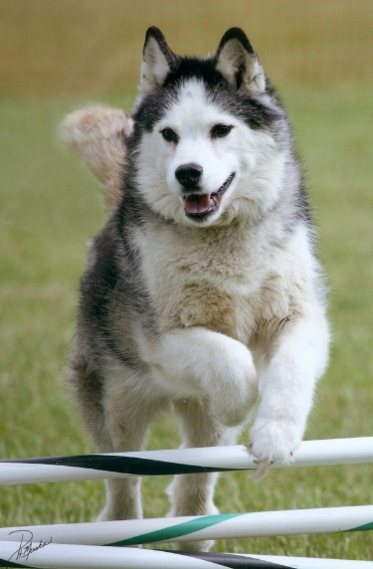

***"Cheetah"***

*Siberian Husky*

*November 2005 – November 2015*

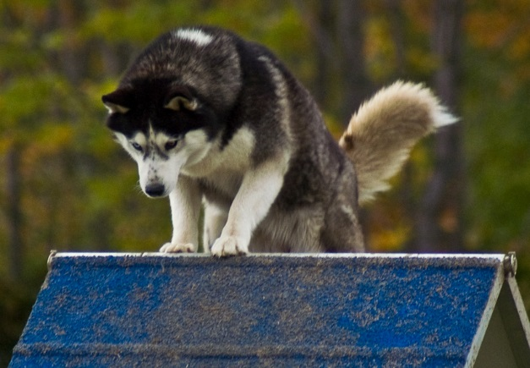

Both were owned and loved by Marian (and Tom) Szebenyi

This year I lost my two "old reliable" agility dogs, Angel and *Cheetah*. They weren't fast, and didn't jump terribly well, but they did what I asked, were a pleasure to have around, and were absolutely safe to take to a demo anywhere.

We got **Angel** as breeding stock, and showed her a little in breed. She never did much in the breed ring, had one litter and then decided she didn't want to do that any more. She got a CD, and Rally titles through RE without much trouble, as well as an AKC NAJ title. Then she developed a problem with her nails which made it painful to land from jumps, come down the A-frame, etc. Eventually use of some dietary supplements took care of this, and she went back into Agility, but in CPE as an Enthusiast, which is easier than AKC, and more fun besides. She has a number of CPE titles and was still going strong, in spite of having developed Cushing's disease. Then one night last spring she took an evening nap and never woke up. She was not quite 12.

***Cheetah*** *was Angel's daughter, the only one that we kept from her litter. Her sire was our red dog Thunder, whom some of you probably remember. We never showed her in breed (her small chunky conformation and tendency to pace rather than trot were not promising in that venue) and were not able to breed her due to a vaginal malformation, but she too got a CD and the Rally titles. In Agility she was a more typical Siberian than Angel, meaning that she had a tendency to take off in the middle of a run to go sniffing some interesting thing, but she eventually settled down and got an AKC NAP and NJP and a number of CPE titles.*

*She was slowing down, probably due to developing arthritis, and was mostly retired as of this year, but still enjoyed getting out occasionally, such as for Agility League, especially if liver cookies were involved. Earlier this year she stared having occasional seizures with no obvious cause. They didn't last that long, or come that often, but then in November, right around her tenth birthday, she had a really bad one from which she did not recover.*

**“Hudson”**

Big Hearts Hudson River Adventure CGC

German Shepherd Dog

5/2/09 - 6/20/15

Owned and loved by Karen Nocera

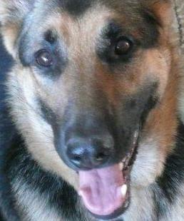

I thought I rescued Hudson, but it turns out we rescued each other. For everything thing I taught her, I learned twice as much. For every ounce of patience I had with her, she had 10 with me. Forever grateful for our brief but life-changing time together.

***“Gus”***

*Gust-o-Fur*

*Border Collie*

*Owned and Loved by Sharon Garland*

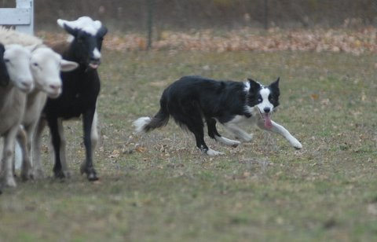

*About 8 years ago, I caved into Nancy Given’s request to just look at a certain website - that they sometimes had Border Collies. NEVER listen to Nancy when she says that. On Thanksgiving 8 years ago I found a BC that was URGENT. He was a spinner and needed out. So Gus made the trip from Bowling Green KY to the north country. The first time I put him on sheep I wondered why I would ever work another dog - he had such talent and desire. Living with me and all the other dogs makes it so everyone gets to do at least one thing and for Gus - it was herding. He loved playing with Zip and the 2 of them would wrestle in the big airline crate – 8# Zip and 45# Gus rolling around.*

*Gus and I competed in AKC, and AHBA - we weren’t quite ever ready for the big field trials, but he titled in his AKC and AHBA venues. His favorite part was working the pens - moving the stock for the competitions. His help on the farm was wonderful l- always happy and willing. If I asked him something too hard - he would do a little comeby spin and then go on - never quite got over the spinning under stress.*

*Gus never asked for much - I am sorry I did not give him more though, for he became ill with carcinomatosis this past summer - which translated to really bad cancer. From a dog never sick 1 day of his life - he left me all too quickly. His final 2 weeks he got to take road trips to Michigan and learn about suburban living - he did like the carpet in the house and he got to ride with head out the window across Canada. On his last day we went to the sheep and let him wander and smell all the smells he loved so much. A happy soul every day of his life - I aspire to be like him in that way (though not circling to the left when I am stressed). Gust-o-fur I am so happy you lived with me.*

**“Rocket”**

Ambertrail Rocket's Red Glare **, SH, CD, WCX, OD, CGC, Can WCI

Golden Retriever

14 Years Old

Owned and loved by Audrey and Bruce Coleman

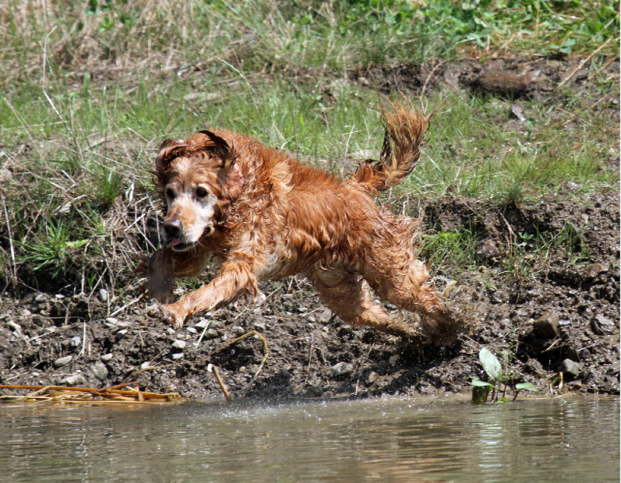

Rocket in 2012

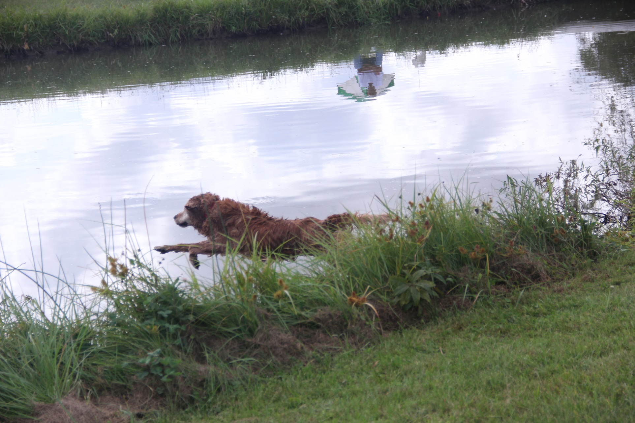

Rocket in 2015: same spirit, enthusiasm and love of the game

It’s two weeks now. The house doesn’t seem the same without her….

In October at the Golden Retriever Club of America National Specialty our 14 year old girl Rocket retrieved 2 pheasants on land. She then leaped into the water like a youngster and retrieved 2 ducks. She did this for the fun of it all as she had previously earned this Working Certificate title.

On November 20th we released her from the pain she suffered from arthritis. With both of us snuggling her and her daughter Fanny by her side she left us. Her love of retrieving and her spirit is what had kept her going.. Those who met her know that she was in for all the cuddling she could get.

Rocket was bred twice and we have Vinny and Fanny from her. Arrow, who is one year older than Rocket, seems a bit lost as the girls grew up together. The household is in flux as the other dogs adjust to a change in the pack. Rocket was the smallest physically but she was the beneficent overseer who stepped in when it was required.

We are so very grateful that we had Rocket this long and during that time she made many people happy. We were fortunate to have been working with Katherine Goldberg DVM who treats only geriatric patients and specializes in hospice and palliative care. Dr. Goldberg came to our home to help us say goodbye to Rocket.

We miss Rocket terribly.

***“Jasper”***

*CT Mtn View Evening in Paris SH, UDX, AX, AXJ, OF, RAE*

*Chesapeake Bay Retriever*

*2/5/01 - 1/8/15*

*Owned and loved by Jan Estes*

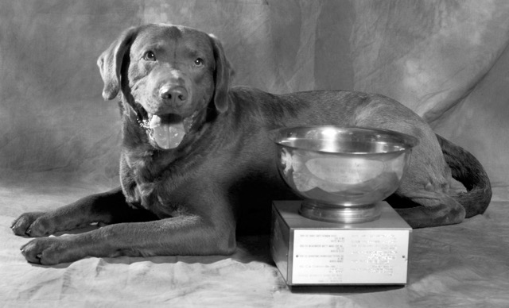

*My first tracking dog, first UDX, first OTCH points, first agility dog. Best dog ever.*

*For the love of dogs we grieve, for the love of dogs we go on.....*